Tetrameter

📏 What is Tetrameter
# Source: AI Source: Provided by: [Data Path: Persons Table -> ID Column: 1, Name_En Column: Motasem Essam] -> From: [Chatgpt (GPT-4-turbo)] on [8/2/2025]
Tetrameter is a poetic meter consisting of four metrical feet per line. It is widely used across English poetry for its balanced rhythm—shorter than pentameter but longer than trimeter—making it highly lyrical and versatile.

🧱 Structure
# Source: AI Source: Provided by: [Data Path: Persons Table -> ID Column: 1, Name_En Column: Motasem Essam] -> From: [Chatgpt (GPT-4-turbo)] on [8/2/2025]
- Each line contains 4 feet.
- Depending on the foot type, this results in 8–12 syllables per line.
- Commonly used foot patterns:
  - Iambic (da-DUM ×4)
  - Trochaic (DUM-da ×4)
  - Anapestic (da-da-DUM ×4)
  - Dactylic (DUM-da-da ×4)

📝 Example

Iambic Tetrameter:
# Source: AI Source: Provided by: [Data Path: Persons Table -> ID Column: 1, Name_En Column: Motasem Essam] -> From: [Chatgpt (GPT-4-turbo)] on [8/2/2025]
I wandered lonely as a cloud
That floats on high o’er vales and hills
— William Wordsworth

Trochaic Tetrameter:
# Source: AI Source: Provided by: [Data Path: Persons Table -> ID Column: 1, Name_En Column: Motasem Essam] -> From: [Chatgpt (GPT-4-turbo)] on [8/2/2025]
Tell me not in mournful numbers
Life is but an empty dream
— Henry Wadsworth Longfellow

🧬 Variants
# Source: AI Source: Provided by: [Data Path: Persons Table -> ID Column: 1, Name_En Column: Motasem Essam] -> From: [Chatgpt (GPT-4-turbo)] on [8/2/2025]
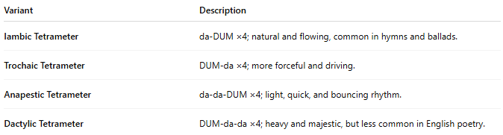
Variant | Description
Iambic Tetrameter | da-DUM ×4; natural and flowing, common in hymns and ballads.
Trochaic Tetrameter | DUM-da ×4; more forceful and driving.
Anapestic Tetrameter | da-da-DUM ×4; light, quick, and bouncing rhythm.
Dactylic Tetrameter | DUM-da-da ×4; heavy and majestic, but less common in English poetry.

🎭 Effect in Poetry
# Source: AI Source: Provided by: [Data Path: Persons Table -> ID Column: 1, Name_En Column: Motasem Essam] -> From: [Chatgpt (GPT-4-turbo)] on [8/2/2025]
- Balanced and musical.
- Often used to:
  - Create momentum
  - Emphasize rhythm
  - Alternate with trimeter in ballads or hymns

📚 Where It's Found
# Source: AI Source: Provided by: [Data Path: Persons Table -> ID Column: 1, Name_En Column: Motasem Essam] -> From: [Chatgpt (GPT-4-turbo)] on [8/2/2025]
- Common in:
  - Ballads
  - Nursery rhymes
  - Religious hymns
  - 19th-century lyric poetry

